**Name:Komal Singh**

**Class: D15B**

**Roll: 60**

**Advance Devops-5**

**Aim: To install and configure terraform on windows**

**Theory:**

Terraform is an infrastructure as code (IaC) tool that allows you to build, change, and version infrastructure safely and efficiently. This includes low-level components such as compute instances, storage, and networking, as well as high level components such as DNS entries, SaaS features, etc.

Terraform can manage infrastructure on multiple cloud platforms. Terraform's state allows you to track resource changes throughout your deployments. You can commit your configurations to version control to safely collaborate on infrastructure. Terraform plugins called providers let Terraform interact with cloud platform and other services via their application programming interfaces (APIs).

**Steps to install terraform:**

1. Go to<https://developer.hashicorp.com/terraform/install?product_intent=terraform>

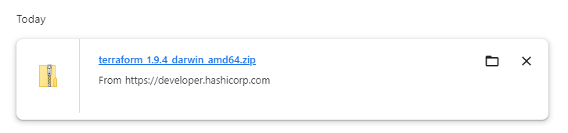

1. Download the file into C:/Terraform

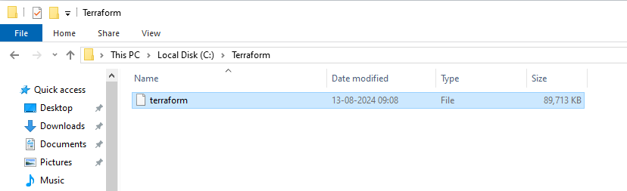

1. Add C:/Terraform in the environmental Variables

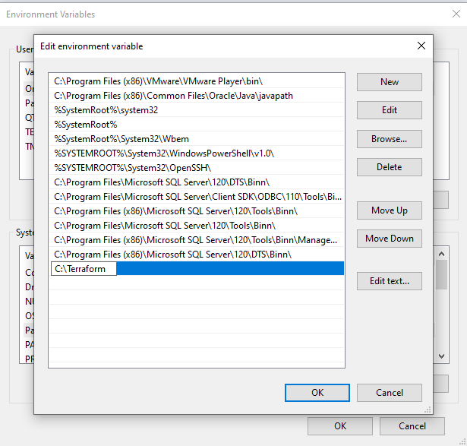

1. Go to CMD and type terraform to check

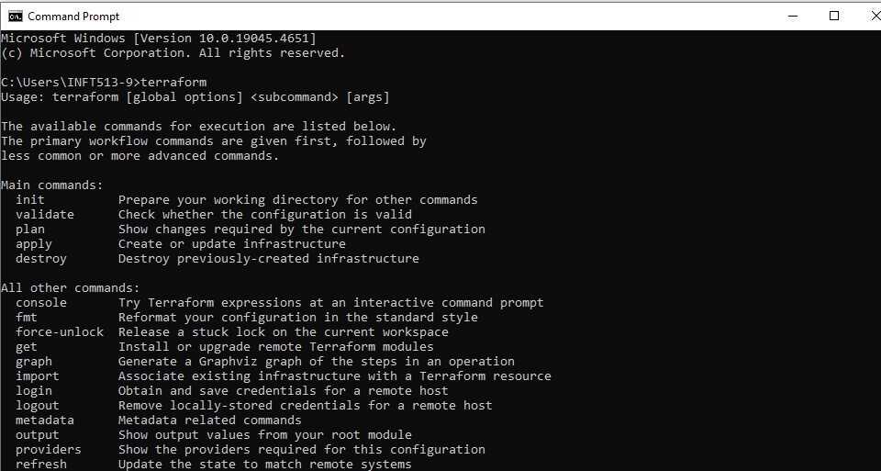

**Conclusion:**  
In conclusion, installing and configuring Terraform on Windows involves downloading the Terraform executable, adding it to your system's PATH, and verifying the installation through the command line. By following these steps, users can efficiently manage infrastructure as code, enabling streamlined deployment and management of cloud resources. With its simple syntax and powerful capabilities, Terraform enhances productivity and collaboration in DevOps practices, making it a valuable tool for modern infrastructure management.